Remy Lagrois

Stats 1 Section 402

HW 4 9/27/15

2.

|  |  |  |  |  |  |  |
| --- | --- | --- | --- | --- | --- | --- |
| **Rank Sum Trauma** | **Mean Rank Trauma** | **Mean Rank** | **SD ranks** | **SD Trauma** | **Z-score** | **P-value (one side)** |
| 67 | 45 | 7.5 | 4.178 | 7.737 | 2.779 | 0.00275 |

The p-value (.00275) allows us to reject the null hypothesis that the medians of the two groups are equal. We accept the alternative hypothesis that the median metabolic expenditure of the trauma group is higher than the not-traumatized group. However we cannot say the increased rate is due to the trauma itself.

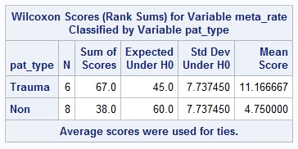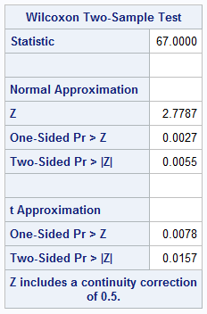3. As can be seen the SAS proc agrees with the hand calculated data. The same conclusions can be made and the package includes a continuity collection.

5. We are investigating whether or not trauma patients have a higher rate of metabolic expenditure than other patients. We assume that the samples are independent of each other. While the distribution of the population is not part of our assumptions we can see that in this case there is little evidence against normality which means our rank sum test performs nearly as well as a t-test. We are not using the t-test though due to the small sample sizes. The mean will be far more sensitive than the median.

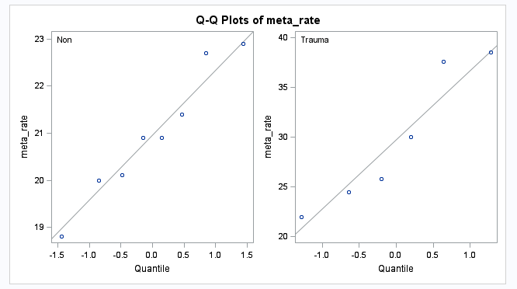

Q-Q plot shows near normal distribution

Our null hypothesis is that there is no difference in the median metabolic expenditure while the alternative is that trauma patients have a higher median than non-trauma patients. We will be using an alpha of 0.05.

Given the one sided p-value of .0027 we reject the null hypothesis of the medians being equal. Instead we accept the alternative hypothesis and conclude the trauma patients have a statistically significant higher metabolism rate at our given alpha. We cannot determine a cause an effect relationship and therefore cannot conclude that the difference is actually due to the trauma itself.

6. For this we performed a Welch’s t-test since the variance between the two groups is not equal. The samples otherwise are independent and there’s not enough evidence to suggest they are not drawn from a normal population. The 95% confidence interval for trauma minus non-trauma is 1.371 to 16.171 indicating there is a difference in the population means and that the trauma patients tend to have a higher metabolic rate.